Section 4.2 Place-Value or Positional-Value Numeration System
Place-Value or Positional-value System: The value of the symbol depends on its position in the representation of the number. For example, the 2 in the number 20 would represent 2 tens and the 2 in the number 200 represents 2 100’s. The most common place-value system is the Hindu-Arabic numeration system. This is used in the United States.

A true positional-value system requires a base and a set of symbols, including a symbol for zero and one for each counting number less than the base.

Decimal Number System: Most common positional system in the base 10 system.

Hindus in India are credited with the invention of zero. The Arabs also adopted the system (hence the Hindu-Arabic numerals). The symbols 0, 1, 2, 3, …, 9 are called digits.

To write a number in expanded form, we use a place-value rule:

In expanded form, 1234 is written:

Babylonian Numerals: Oldest known numeration system [2500 B.C.] Place-value system with a base of 60. Lacked a symbol for zero which led to a great deal of ambiguity and confusion.
unit symbol, 10s symbol, subtraction symbol | The positional values in the Babylonian system are

Example 1: Write 62 with Babylonian Symbols.

Example 2: Write as a Hindu-Arabic numeral

Example 3: Write as a Hindu-Arabic numeral

Example 4: Write as a Hindu-Arabic numeral.

Converting from Hidu-Arabic To Babylonian:
Need to think in terms of time. Convert into hours, minutes, and seconds.
(3600 seconds in an hour, 60 seconds in a minute, and 60 minutes in an hour)

Example 5: Write 4871 as a Babylonian Numeral.

Example 6: Write 7223 as a Babylonian Numeral.

Example 7: Write 9820 as a Babylonian Numeral.

Mayan Numerals: Written vertically with units’ position on the bottom.

The positional values in the Mayan system are

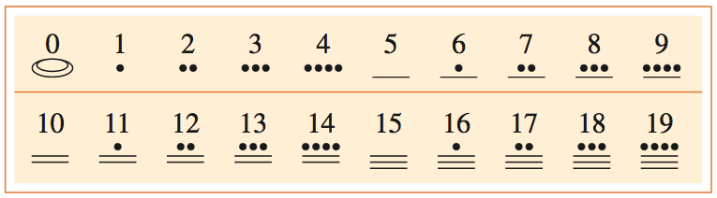

Example 8: Write as a Hindu-Arabic numeral.

Example 9: Write 4025 as a Mayan numeral.

